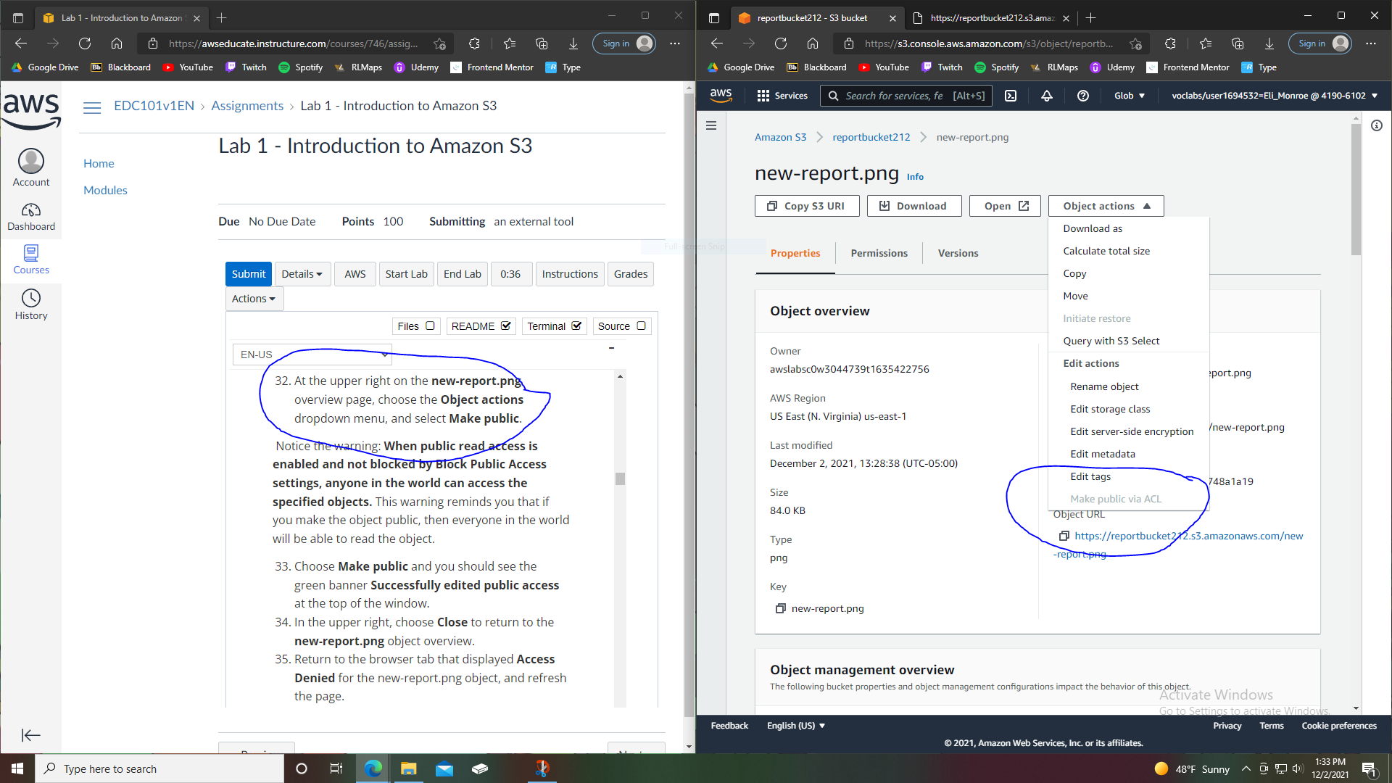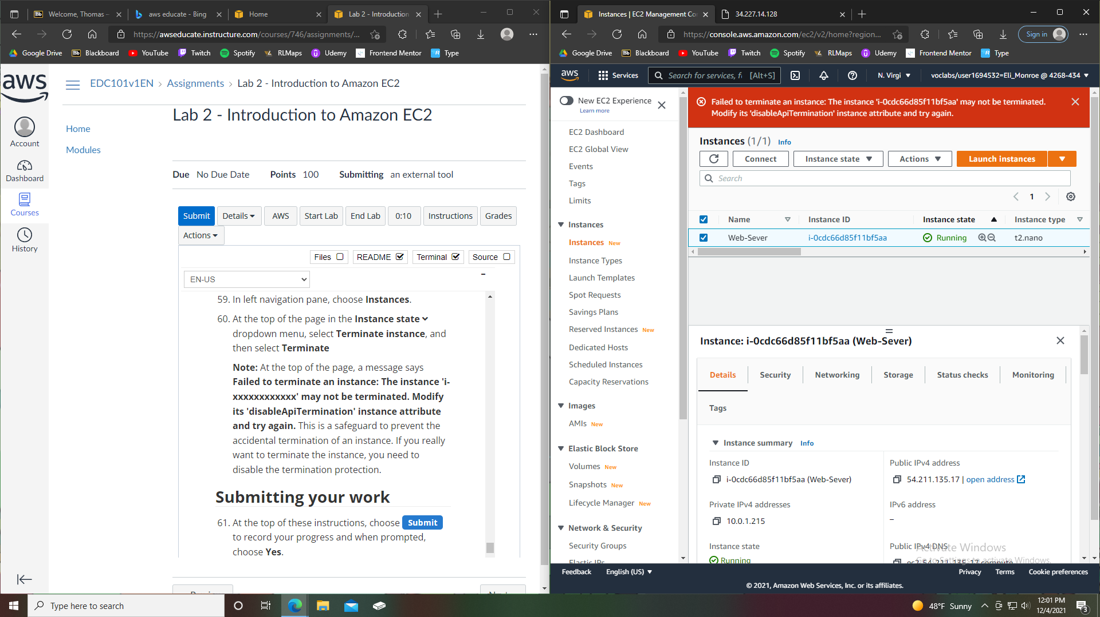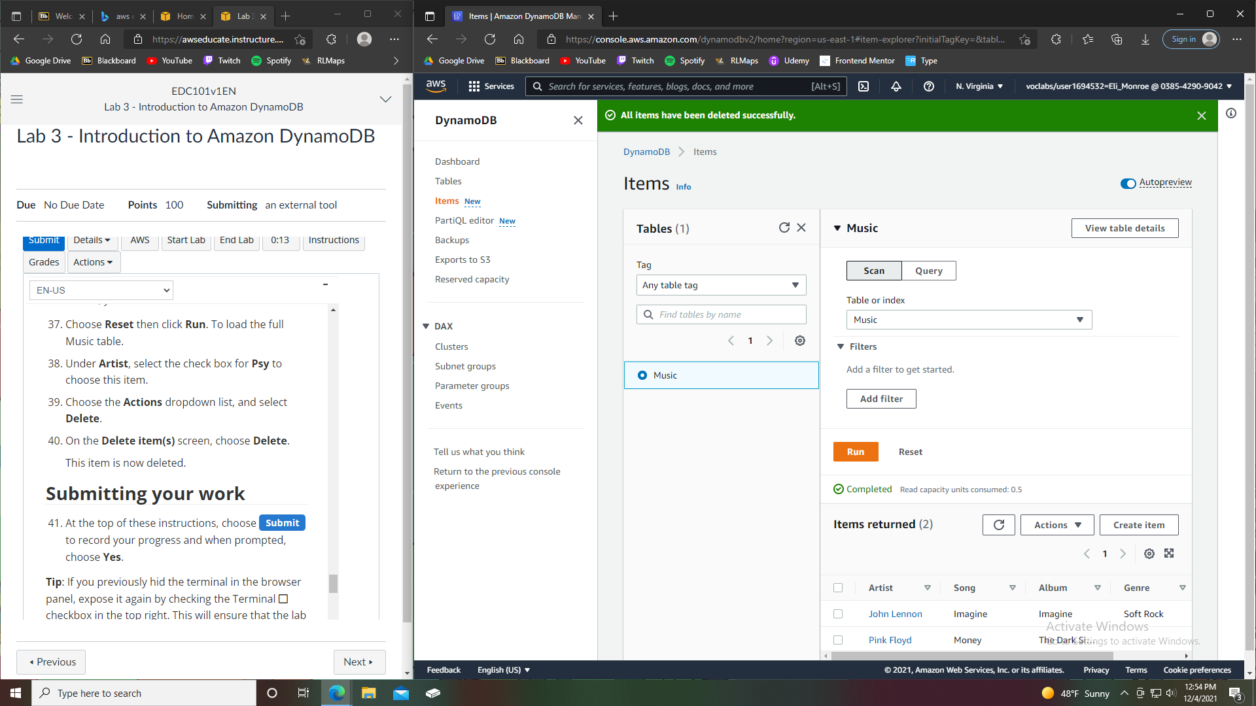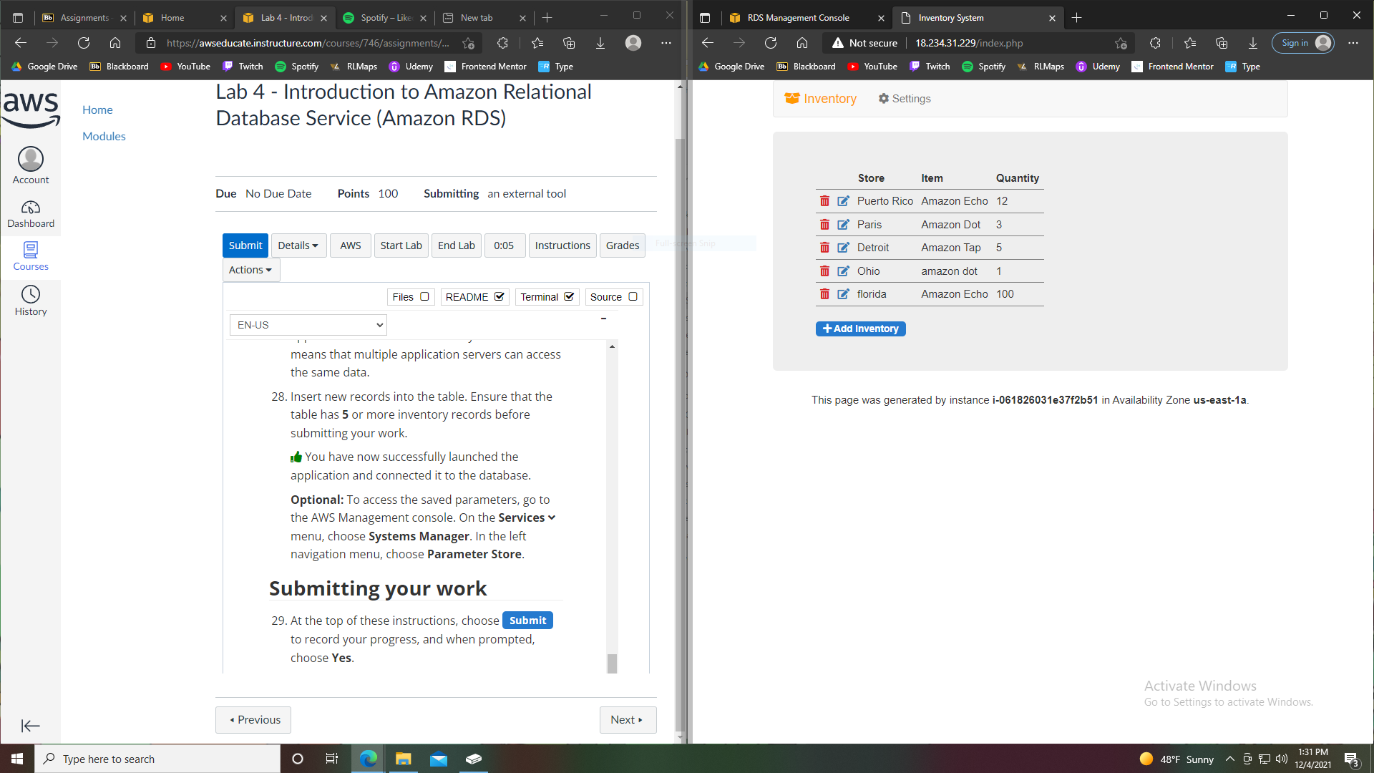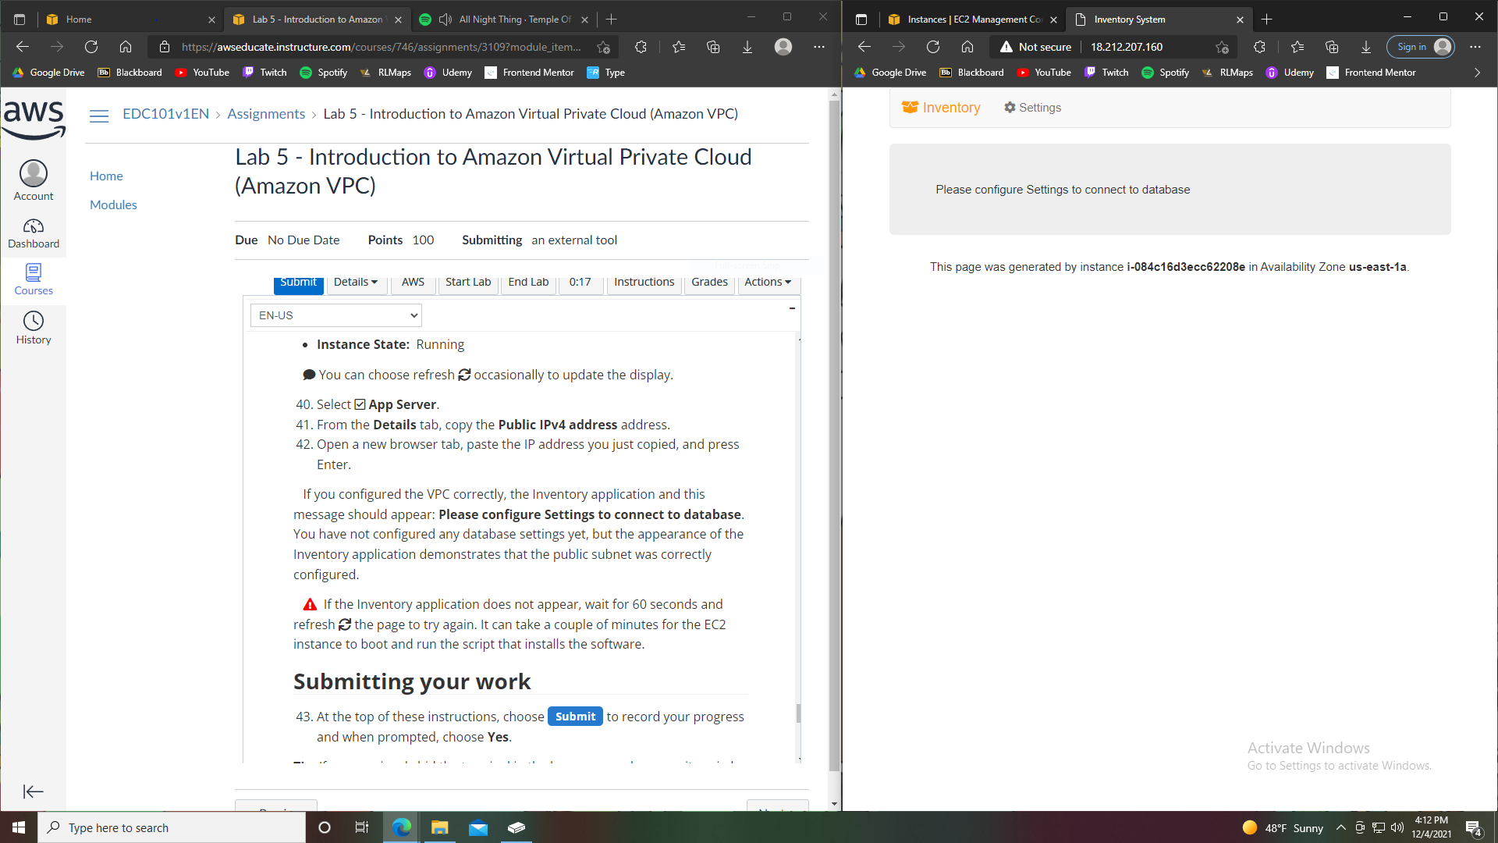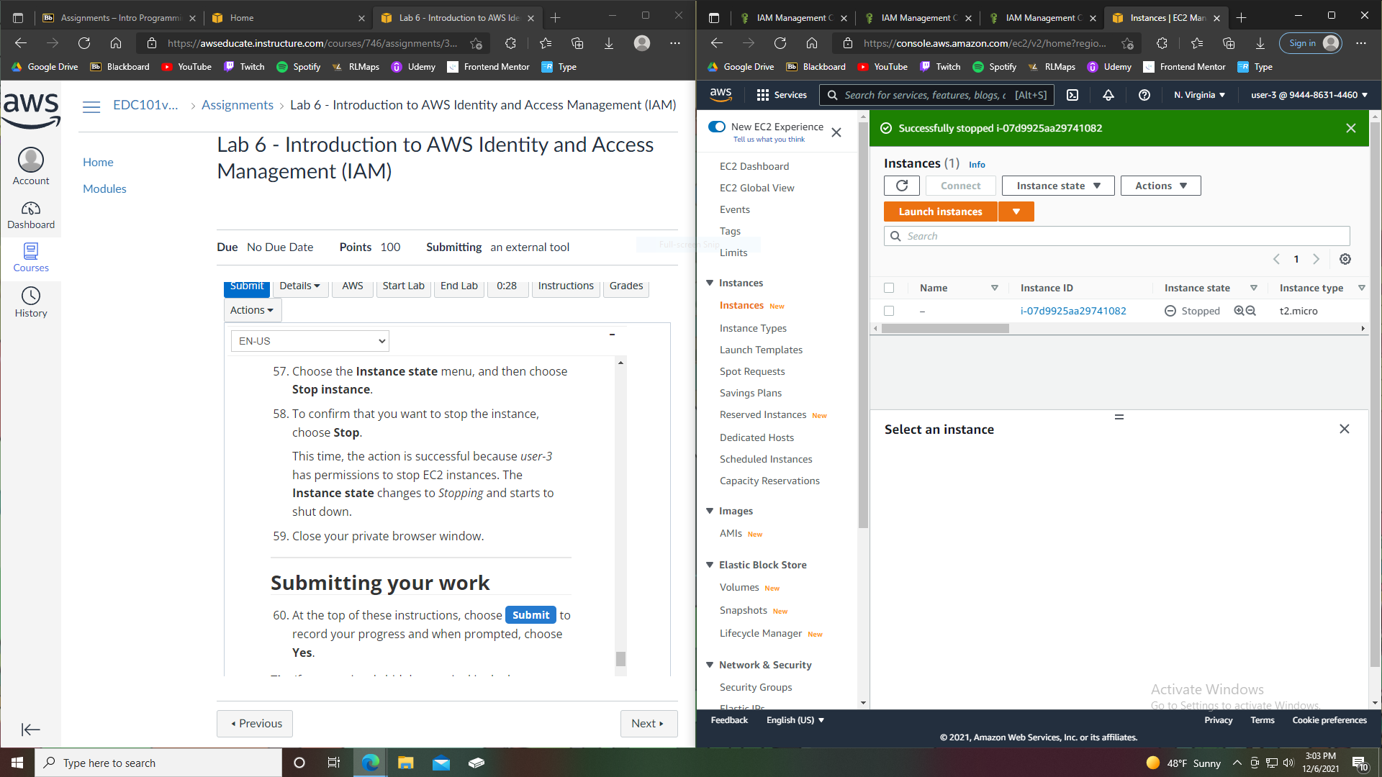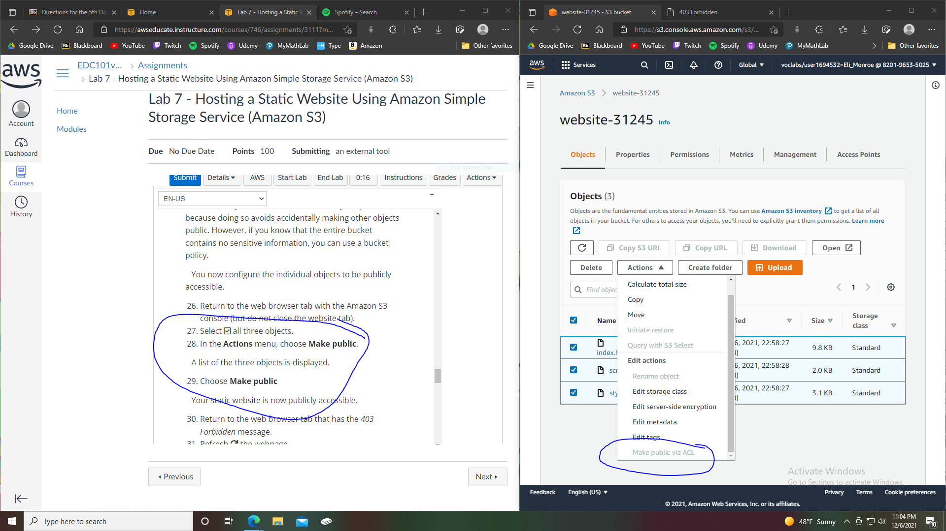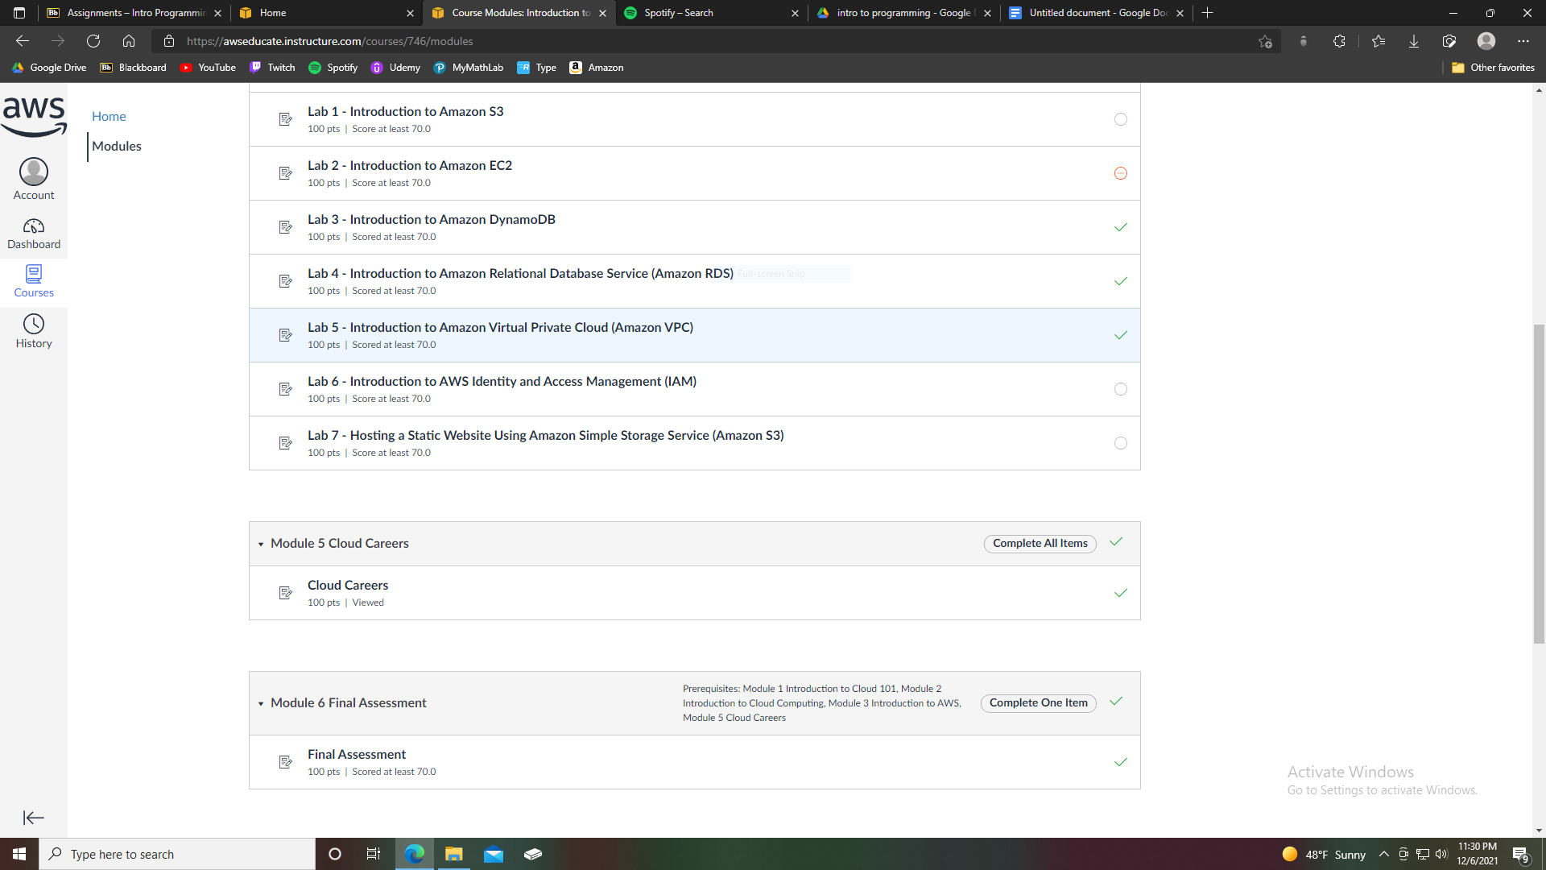For the first and last labs I was unable to make the bucket public even after enabling the ability to do so. The second lab's grading was weird; it was testing for an incorrect instance rather than what was told in the lab. While attempting to submit the 6th lab aws crashed and would not allow me to access any labs or submit any labs. Labs 3, 4, and 5 all graded fine. I was very excited to take the end of course survey offered. Thank you for your understanding.